Day 1 and 2 – Prepare to shrink to the size of an ant.
WALT identify synonyms for different words.

What are synonyms?
Synonyms are words or phrases that mean exactly the same or nearly the same and another word or phrase.
For example synonyms for the word ‘walk’ could be:
- Stroll
- Saunter
- Amble
- Plod
- Hike

DAY 1
Create your own chart or poster showing synonyms for the word ‘small’ look at some examples of posters below.

DAY 2
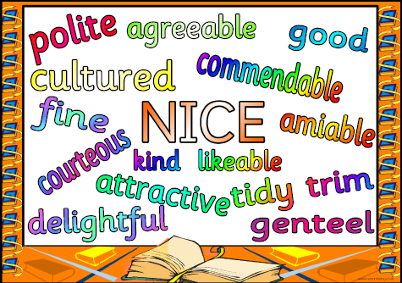
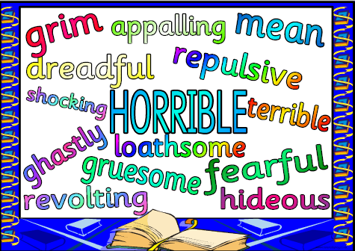
Create your own chart or poster showing synonyms for the word ‘big’ look at some examples of posters below.

