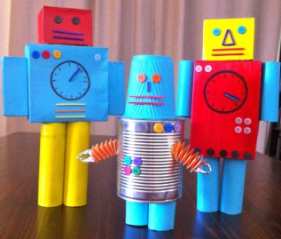
Day 1. Talk through how the robot was made, remember to use time words and bossy verbs. Use the word lists below to help you build your sentences. Once you have talked through your sentences next you should try and get them down on paper. Remember to put them in the correct order.
Time words | Bossy Verbs
First  Then  When  Next  After  Finally | put  stick  draw  glue  add  roll  bend  flatten  slide
Once you have finished your writing, read it through aloud. Check you have remembered your capital letters and full stops.

