Day 2 – Prepare to shrink to the size of an ant
WALT infer what a character is thinking.

Watch ‘Day 2 – Honey, I shrunk the kids clip 2’ on file or online at https://www.youtube.com/watch?v=_C3vNjFIrow&list=PLDbbJgth3HgkGSexOfJ967k-0nLHcQ7xT&index=8

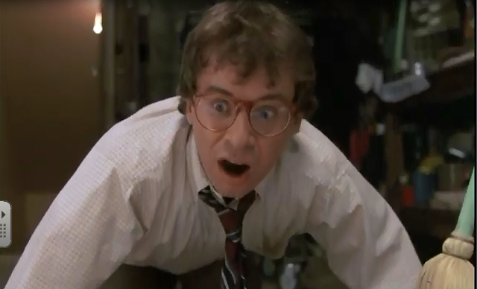
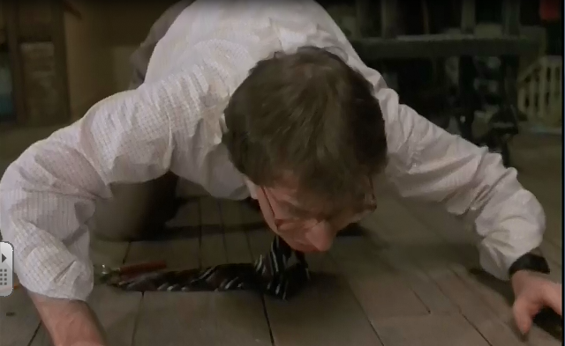
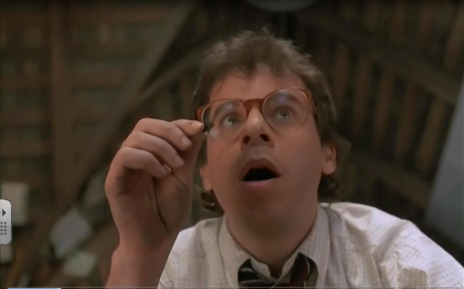
In this clip Wayne says very little but his actions and reactions help to tell the story. Inside the thought bubbles next to each picture, write out what Wayne would be thinking or feeling. Some of your answers might be single words or short phrases

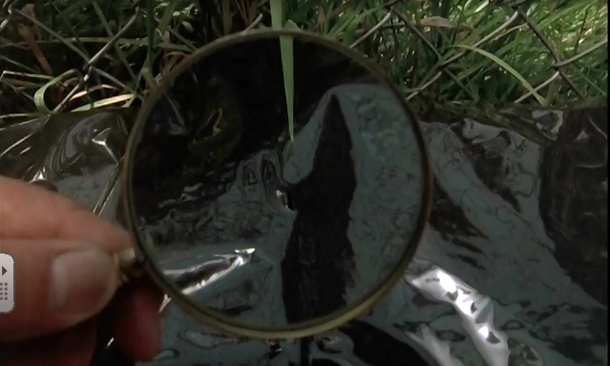

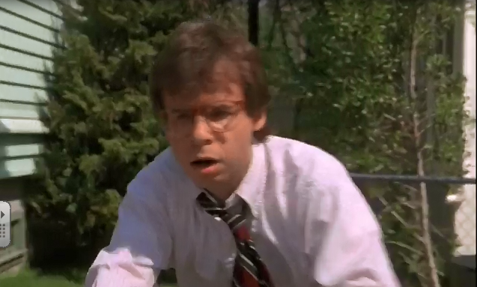

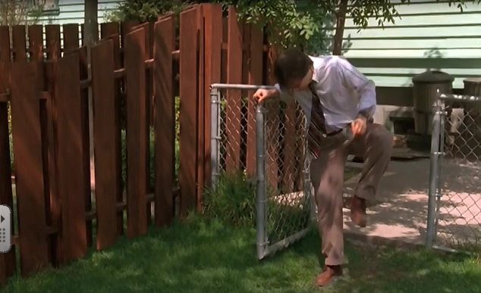

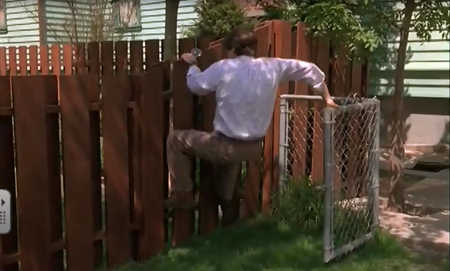

Why not replay the clip and read aloud your thought bubbles at the key moments.

