Vision Screening in Lancashire Schools
What is vision screening?
Vision screening is when a specially trained person checks your child’s vision to make sure they can see without any problems. The aim of the service is to detect reduced vision early, to reduce the risk of defects developing into visual impairments if left untreated.
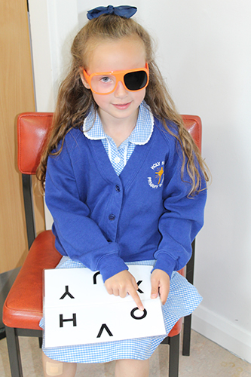
What is involved with vision screening?
Your child’s vision will be assessed using a letter matching test. The test is fun and your child does not need to know their letters to complete it. During the test a pair of glasses with one eye blanked out will be used or an eye patch will be placed over one eye to test each eye separately. The test is entirely safe and children enjoy playing the letter matching game. It takes approximately five minutes and the screener is trained to make this fun for the child.

Who does the screening?
Blackpool Teaching Hospitals NHS Foundation Trust and East Lancashire Hospitals NHS Trust provide specially trained vision screeners go to every school in Lancashire and see children in the reception class. As NHS staff they are all DBS checked, (Disclosure and Barring Service. This check was previously known as CRB, Criminal Records Bureau).

Does my child have to be screened?
No. However, we strongly recommend that your child is screened for vision defects; however you have the right to decline the assessment. No screening will take place without your consent. A letter will be sent home with your child informing you about the screening; this is an Opt-out letter and only needs to be returned if you do not wish for your child to be tested. If you do not receive a letter please ring the school for a copy.

What happens if my child is absent on the day of screening?
An appointment will be offered at a local health centre for your child to be tested. A member of the vision screening team will send an appointment letter to your home address for this.

What will happen during the vision screening assessment?
Your child’s vision will be assessed using a letter matching test. The test is fun and your child does not need to know their letters to complete it. During the test a pair of glasses with one eye blanked out will be used or an eye patch will be placed over one eye to test each eye separately. The test is entirely safe and children enjoy playing the letter matching game. It takes approximately five minutes and the screener is trained to make this fun for the child.

What happens if my child passes the assessment?
If your child passes you will receive a letter informing you of the result. This means that at the moment their vision in both eyes is as expected for their age. This result does not rule out potential future eye problems. Children’s eyes change as they grow so if you have any concerns about your child’s eyes at any stage in the future, contact your local optometrist (optician) or GP.

What happens if my child does not pass the assessment?
If your child does not pass, you will receive a letter informing you of the result. Your child will be referred to your local orthoptic department and you will receive a letter in the next few weeks from the hospital inviting you to an appointment for further tests.
It is important to attend the appointment for further tests to confirm your child’s results and if treatment is required. Reduced vision may be caused by the child needing glasses or a turn in the eye (squint). Glasses and/or eye patches may be recommended as treatment for these problems. These tests could be carried out by an Orthoptist, who manage visual disorders related to eye development or misalignment, an Optometrist who can prescribe glasses if required, or an Ophthalmologist, depending on the results of the screening.
Sometimes a child does not pass the screening because they are tired or not able to concentrate on the day of screening. If the vision screener feels this may be the case on the day, you will be asked to attend another appointment for a recheck.

Contact details
Lancashire Vision Screening Team at Blackpool Victoria Hospital
Tel: 01253 953457
Email address: bfwh.lancashirevisionscreeningservice@nhs.net

