 | Autumn 1  8 weeks | Autumn 2  7 weeks | Spring 1  6 weeks | Spring 2  5 weeks |  | Summer 1  7 weeks | Summer 2  6 weeks
Topic | Ourselves and Our Community | Let’s Celebrate | The Queen |  | Down at the Bottom of the Garden | 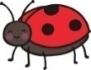  Brilliant Beasts | India and under the sea  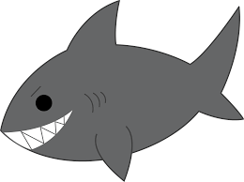
Characteristics of Effective Teaching and Learning | Playing and Exploring  Active learning  Creating and thinking critically  All aspects weave through all areas of learning throughout this half term. | Playing and Exploring  Active learning  Creating and thinking critically  All aspects weave through all areas of learning throughout this half term. | Playing and Exploring  Active learning  Creating and thinking critically  All aspects weave through all areas of learning throughout this half term. | Playing and Exploring  Active learning  Creating and thinking critically  All aspects weave through all areas of learning throughout this half term. |  | Playing and Exploring  Active learning  Creating and thinking critically  All aspects weave through all areas of learning throughout this half term. | Playing and Exploring  Active learning  Creating and thinking critically  All aspects weave through all areas of learning throughout this half term.
Communication and Language | - Good sitting and listening routines.  - Enjoy a story.  - Sing a repertoire of songs and rhymes. | - Learn and use a wide range of vocabulary.  - Sing a repertoire of songs and rhymes.  - Start a conversation with an adult or a friend. | - Listen to a story and recall key events.  - Learn and use a wide range of vocabulary.  - Sing a large repertoire of songs and rhymes. | - Learn and use a wide range of vocabulary.  - Sing a large repertoire of songs and rhymes.  - Ask questions to find out more.  - Have a familiarity and understanding about stories. |  | - Learn and use a wide range of vocabulary.  - Sing a large repertoire of songs and rhymes.  - Talk to organise play.  - Speak in well formed sentences.  - Describe events in detail.  - Explain how things work. | - Learn and use a wide range of vocabulary.  - Sing a large repertoire of songs and rhymes.  - Connect ideas using connectives.
Personal, Social and Emotional Development. | - Introduce Focus Freddie.  - Class rules and expectations.  - Sharing and taking turns.  - Making new relationships.  - Able to leave their adult.  - PSHE scheme | - Class rules and expectations and moderate behaviour accordingly.  - Sharing and taking turns.  - Making new relationships.  - PSHE scheme | - Rules and why we have to follow them.  - Seeing themselves as a valuable individual.  - PSHE scheme | - Caring for others.  - Building respectful relationships.  - PSHE scheme |  | - Caring for creatures and looking after them.  - Talk about being scared and taking risks.  - Express feelings of self and others.  - Resilience and perseverance in the face of challenge.  - PSHE scheme | - Kidsafe  - Trying something new.  - Keeping safe.  - Safety at the seaside and use of suncream.  - PSHE scheme
Physical Development. | Lancashire PE Scheme of Work 2020- Themes  ‘Welcome to PE’ Progression 1-6 Transport Theme Progression 1 &2  Squiggle whilst you wiggle  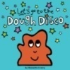  Dough disco | Lancashire PE scheme of work 2020 – stories  ‘How to Catch a Star by Oliver Jeffers’  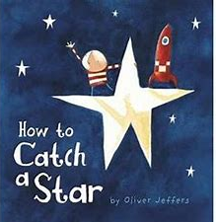  Progression 1-5  Squiggle whilst you wiggle  Dough disco  Teach Mr Crocodile and begin to have control of a pencil. | Lancashire PE Scheme of Work 2020- Themes  ‘Castles’  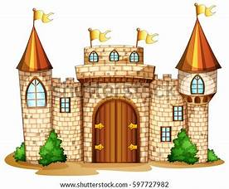  Progression 1-5  Squiggle whilst you wiggle  Dough disco  Comfortable grip and good pencil control. | Lancashire PE scheme of work 2020 – stories  ‘Jack and the Beanstalk’  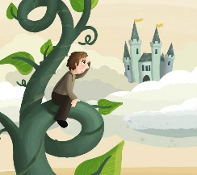  Progression 1-5  Squiggle whilst you wiggle  Confidently use pencils for drawing and writing. |  | Lancashire PE Scheme of Work 2020- Themes  ‘Minibeasts’  Progression 1-6  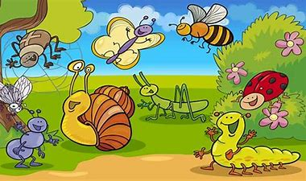  Squiggle whilst you wiggle  Develop a fast and efficient hand writing style. | Lancashire PE Scheme of Work 2020- Themes  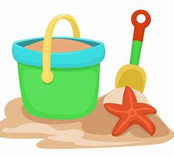  ‘Seaside’  Progression 1-5’  Squiggle whilst you wiggle  Develop a fast and efficient hand writing style.
Literacy | - Skill - narrative  - Fiction - The Three Little Pigs and variations  - Non fiction – Homes around the world and Houses and Homes.  - Poetry –Wheels on the bus – change to about a house.  - In every house on every street. | - Skill posters/instructions  - Fiction – Kipper’s Birthday and The Toy Party (make cake from the bok)  - Goldilocks.  - Peace at Last  - Owl babies  - Non fiction – Nocturnal animals.  - Poetry – 5 little Owls and The wise old owl | - Skill - lists  - Fiction –The Queens hat/The Queens handbag/ The Queens knickers  - Non fiction – London  - Poetry – There was a princess long ago, the Grand Old Duke of York and sing a song of sixpence.  - Poetry basket – I can build a snowman/carrot nose | - Skill – recipe/innovation of evil pea character  - Fiction – Oliver’s Fruit Salad  Jasper’s Beanstalk  The Tiny Seed.  Supertato  - Non fiction – Healthy eating and growing and planting  - Poetry basket - pancakes |  | - Skill – reporters video  - Fiction – Snail, snaily snails  - The very hungry Caterpillar  - Superworm  - Non fiction – Usborune beginners Nature books and fact books about minibeasts.  - Books about Spiders.  - Poetry – Mad about minibeasts | - Skill narrative – writing own story  - Fiction –  - Billy’s Bucket  - What the ladybird heard on holiday.  - Tiddler  - The runaway chapatti  - Non fiction – little dreams big people Mahatma Gandhi  - Surprising hsarks  - Poetry – Seaside Poems.  - Commotion in the ocean
Maths | Key learning introduced through Numberland:  Rote counting Counting objects Shape | Key learning introduced through Numberland:  Number sense Number recognition Number graphics Calculating | LAPS Spring term  Counting and comparing  Partitioning and understanding part-whole  Understand teen numbers  Distance- length, height,width  Opportunity to apply number 20  Mass, weight, capacity,volume  Shape and sorting | LAPS Spring term  Addition  Subtraction  Halving and doubling  Number sense  Addition and subtraction x2 weeks |  | LAPS Summer term  Counting, comparing and ordering  Whole addition and subtraction  Fractions  Distance- length, height,width,weight  Capacity- volume and money  Shape and sorting | LAPS Summer term  Time  Space  Money and sorting  Number sense  Addition and subtraction  Addition and subtraction
Understanding the World. | - Materials  - Body Parts  - Our community  - Types of houses  - Talk about out families.  - RE – Special times including Harvest, Eid, Diwali and Christmas.  - Use our senses to explore natural materials | - Bonfire Night (Guy Fawkes) and the night sky  - Autumn  - How do leaves fall experiment  - Light and Dark  - RE – Special times including Harvest, Eid, Diwali and Christmas.  - Make porridge | - Winter – ice experiment  - Pancake Day  - The Queen  - Links between family members.  - Healthy eating.  - Morecambe and places in the world/UK/london look at similarities and differences.  - RE – What stories and books are special for different people and why? | - Spring  - Fruit and vegetables  - Different parts of a plant.  - Plant seeds and care for them.  - Rainbows and puddles  - RE – What stories and books are special for different people and why? |  | - Life cycles and minibeasts. Grow your own butterflies.  - Summer  - RE – What is special about our world? Learn about the creation story in different faiths. | - The seaside.  - Rock pools  - Weather  - Forces - floating  - Different countries.  - RE – What is special about our world? Learn about the creation story in different faiths.
Expressive Arts and Design | Music Charanga Unit: Me  Learn to sing nursery rhymes and action songs including Head, shoulders, knees and toes.  Portraits  Explore different materials.  Mondrian and Kandinsky. | Music Charanga Unit: My stories  Learn to sing more nursery rhymes and action songs.  Christmas crafts – include a skill in the making.  Mixing colours to make fireworks.  Rangoli patterns  Make a chair for baby bear | Music Charanga Unit: Spring  Learn to sing more nursery rhymes and action songs.  Make Union Jack flags for garden party and to wave in singing the National anthem.  How to paint/draw your own royal portrait- Make a royal gallery using different media each day- watercolours  Cecil beaton | Music Charanga Unit: Our World  Learn to sing more nursery rhymes and action songs.  Paint/exploration using vegetables.  Van gogh - sunflowers  Observational drawings of fruit and vegetables using different media. |  | Music Charanga Unit: Big Bear Funk  Create your own pet minibeast with made up features from lots of different minibeasts. Add other materials.  Matisse snail art  Innovate nursery rhymes and songs | Music Charanga Unit: Reflect, rewind,replay.  Holi  Hand print Indian animals  Indian songs/ instruments

