Home Learning
Year 2 w/c Monday 13th July 2020 English Topic – Prepare to shrink to the size of an ant.
Daily tasks – Please practise these tasks every day for at least 10 minutes for each task
Spellings | Continue to practise the year group spellings we sent home in March and have a go at practising your spellings using these websites:  https://spellingframe.co.uk/  http://www.ictgames.com/mobilePage/spookySpellings/index.html  http://www.ictgames.com/mobilePage/lcwc/index.html
Maths | Remember to keep on practising your number facts!
Daily Reading | Keep on reading a range of materials that you have at home including books, recipes, newspapers/magazines, game instructions/manuals, Oxford Reading Owls (free e books) https://www.oxfordowl.co.uk/for-home/find-a-book/library-page
Pick and Mix Activities
The Borrowers made lots of things using everyday objects at home. Why not try making your own pan flute using things you should have in your house.  https://buggyandbuddy.com/homemade-straw-pan-flutes/ If you follow the instructions carefully you could also share your song with a friend and they could try playing it at home too. | Let’s go on an ‘Outdoors Hairstyle Hunt’  Using a piece of cardboard, draw and cut out a funny face with ears but importantly no hair. Now take it outside, and with an adult go on a ‘Hairstyle Hunt’! See how many funny hairstyles you can give it, using grass, leaves, twigs – what else can you use to create a wig? Take some photos and send them in we would love to see them. | Fancy something yummy and refreshing on a hot summer’s day? Why not make your own ice-lollies? Make your ice-lollies with diluted fruit juice and lolly stick. Pop them in your freezer and enjoy hem whenever it is hot and sunny. You might want to be adventurous and add more ingredients like fresh fruit or yoghurt.
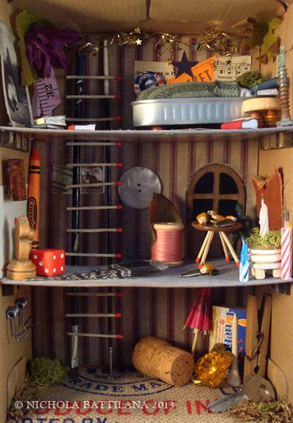  Using things in your homes that the Borrowers might borrow. Could you design and make a room that could go under the floorboards. Think about what the borrowers would need...beds, chairs, tables What else do you think they would need? | Living in secret, the Borrowers had to learn to be as quiet as possible. They spent lots of their time playing games as a family under the floorboards. Why not play the Alphabet Game? You have to pick a subject (it can be any at all, use the list below for inspiration) and write down one answer for each letter of the alphabet.  - Boys name  - Girls names  - Countries or cities  - Food  - Chocolate bars  Or why not pick a subject of your own? Why not have a competition with someone in your family. Who can complete the list first? | The Borrowers are used to finding things in the house, but are you? Why not create your own treasure hunt in your house? It could be indoors, outdoors or even a mix of both. https://www.thespruce.com/indoor-treasure-hunt-for-children-1695332  The following website give you some clues are to how your treasure hunt could be laid out. Could you work out where the next clue is based on this one?  I'm hungry! I'm hungry! Please feed me a slice.  I'll spit it back out all brown and nice.
Your class teacher would love to see some examples of the work you are producing. You can email your class teacher any photos of your work to the following email address: c.year2a@westgatesch.com

