Home Learning- Reception w/b 13th July 2020 (1 week)
Daily tasks – Please practice these tasks every day for at least 10 minutes for each task
Phonics | This week in phonics we would like you to practise your tricky words. These are words that cannot be sounded out, we just have to learn them. Can you practise reading and writing them?  Phase 2 tricky words – I, to, no, go, the, into  Phase 3 tricky words – he, we, me, be, she, you, was, all, are, they, was, my  And if your brain would like to get really big have a go at the phase 4 words – said, have, like, so, do, some, come, little, one, were, out, what, when.  Use the phase 2 and 3 resources and play the game tricky word trucks on phonics play to help you practise.  www.phonicsplay.co.uk which is still free to use with this log in  Username: march20 Password: home
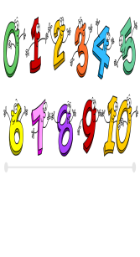  Maths | This week we are going to look at halving.  Can you halve a piece of paper? How many bits did you have now? Try with lots of different pieces of paper. Now can you halve an amount? When you are halving it is always sharing between two and they must have the same amount each. For example I had 6 apples and 2 teddies. I said, ‘one for you and one for you’ until I had shared out all my apples and found they had 3 each. Can you now halve these numbers and find out the answer, use your toys, food, family and anything else you can find to share. What is half of 6, 8, 10, 4, 2, 12, 14, 16, 18 and 20?
Daily Reading | Keep on reading all the different things that you have at home. You can continue using Oxford Reading Owls (free e books) https://www.oxfordowl.co.uk/for-home/find-a-book/library-page  Log in is - Username- westgate  Password- westgate (All lower case)  Once you have logged on, go to ‘My Bookshelf’ and search for ages 4-5 or 5-6 in the filter bar. Here you will find a large selection of eBooks. Have a look through and choose one that looks interesting and read it. You could always record what you have read in your reading record.
Pick and Mix Activities: Snail and the Whale
Create your own Under the Sea scene in a box. What sea creatures will you include? Can you include sand and shells?  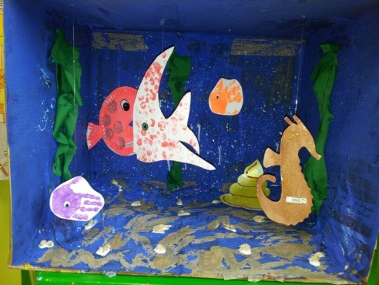 | Can you create your own snail? Where will this snail travel?  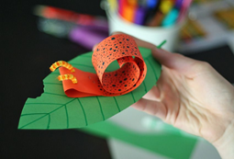 | Create your own fish hand puppet by drawing around your hand and cutting it out, then decorate it. Remember to take your time when using scissors!  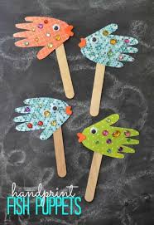
Can you create your own food chain for a sea creature? What does a fish eat? What eats the fish? Does anything eat that? An example is below but you could draw it on paper, make a mobile or make a chain on the floor. Remember to take a photograph and send it to us!  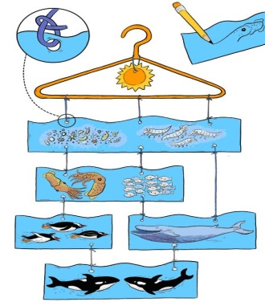 | Use an atlas or a map on the internet to look at all the places the snail and the whale visited. Which places would you like to visit and why? | The Little Mermaid lived under the sea! Why not try to learn the song or make up a dance to go with it? We would love to see some clips!  https://www.youtube.com/watch?v=GC_mV1IpjWA

The story is also available to watch on BBC iPlayer follow the link below.
https://www.bbc.co.uk/iplayer/episode/m000cslw/the-snail-and-the-whale
Your class teacher would love to see some examples of the work you are producing. You can email your class teacher any photos of your work to the following email
address...c.rec1@westgatesch.com

