 | Autumn 1  8 weeks | Autumn 2  7 weeks | Spring 1  6 weeks | Spring 2  5 weeks |  | Summer 1  7 weeks | Summer 2  6 weeks
Topic | Ourselves and Our Community | Let’s Celebrate | The Queen |  | Down at the Bottom of the Garden | 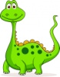  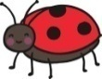  Brilliant Beasts | Happy Holidays!
Characteristics of Effective Teaching and Learning | Playing and Exploring  Active learning  Creating and thinking critically  All aspects weave through all areas of learning throughout this half term. | Playing and Exploring  Active learning  Creating and thinking critically  All aspects weave through all areas of learning throughout this half term. | Playing and Exploring  Active learning  Creating and thinking critically  All aspects weave through all areas of learning throughout this half term. | Playing and Exploring  Active learning  Creating and thinking critically  All aspects weave through all areas of learning throughout this half term. |  | Playing and Exploring  Active learning  Creating and thinking critically  All aspects weave through all areas of learning throughout this half term. | Playing and Exploring  Active learning  Creating and thinking critically  All aspects weave through all areas of learning throughout this half term.
Communication and Language | - Good sitting and listening routines.  - Enjoy a story.  - Sing a repertoire of songs and rhymes. | - Learn and use a wide range of vocabulary.  - Sing a repertoire of songs and rhymes.  - Start a conversation with an adult or a friend. | - Listen to a story and recall key events.  - Learn and use a wide range of vocabulary.  - Sing a large repertoire of songs and rhymes. | - Learn and use a wide range of vocabulary.  - Sing a large repertoire of songs and rhymes.  - Ask questions to find out more.  - Have a familiarity and understanding about stories. |  | - Learn and use a wide range of vocabulary.  - Sing a large repertoire of songs and rhymes.  - Talk to organise play.  - Speak in well formed sentences.  - Describe events in detail.  - Explain how things work. | - Learn and use a wide range of vocabulary.  - Sing a large repertoire of songs and rhymes.  - Connect ideas using connectives.
Personal, Social and Emotional Development. | - Introduce Focus Freddie.  - Class rules and expectations.  - Sharing and taking turns.  - Making new relationships.  - Able to leave their adult. | - Class rules and expectations and moderate behaviour accoirdingly.  - Sharing and taking turns.  - Making new relationships. | - Rules and why we have to follow them.  - Seeing themselves as a valuable individual. | - Caring for others.  - Building respectful relationships. |  | - Caring for creatures.  - Talk about being scared and taking risks.  - Express feelings of self and others.  - Resilience and perseverance in the face of challenge. | - Kidsafe week.  - Trying something new.  - Keeping safe.  - Road safety.
Physical Development. | Lancashire PE Scheme of Work 2020- Themes  ‘Welcome to PE’ Progression 1-6 Transport Theme Progression 1 &2  Squiggle whilst you wiggle  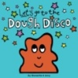  Dough disco | Lancashire PE scheme of work 2020 – stories  ‘How to Catch a Star by Oliver Jeffers’  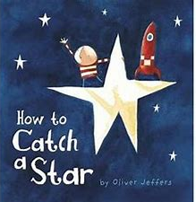  Progression 1-5  Squiggle whilst you wiggle  Dough disco  Teach Mr Crocodile and begin to have control of a pencil. | Lancashire PE Scheme of Work 2020- Themes  ‘Castles’  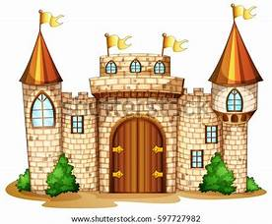  Progression 1-5  Squiggle whilst you wiggle  Dough disco  Comfortable grip and good pencil control. | Lancashire PE scheme of work 2020 – stories  ‘Jack and the Beanstalk’  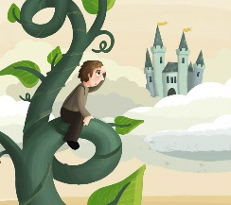  Progression 1-5  Squiggle whilst you wiggle  Confidently use pencils for drawing and writing. |  | Lancashire PE Scheme of Work 2020- Themes  ‘Minibeasts’  Progression 1-6  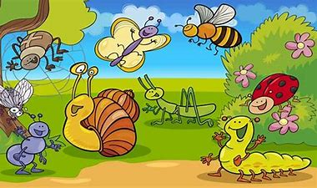  Squiggle whilst you wiggle  Develop a fast and efficient hand writing style. | Lancashire PE Scheme of Work 2020- Themes  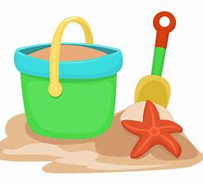  ‘Seaside’  Progression 1-5’  Squiggle whilst you wiggle  Develop a fast and efficient hand writing style.
Literacy | - Fiction - The Three Little Pigs.  - Non fiction – Homes around the world and Houses and Homes.  - Poetry –Wheels on the bus. | - Fiction – Kipper’s Birthday and The Toy Party  - Goldilocks.  - Peace at Last  - Non fiction – Nocturnal animals.  - Poetry – 5 little Owls | - Fiction – Royal Dinner  - Non fiction – Castle and king and queens books.  - Poetry – There was a princess long ago and the Grand Old Duke of York. | - Fiction – Oliver’s Fruit Salad  Jasper’s Beanstalk  The Tiny Seed.  Supertato  - Non fiction – Healthy eating / people who help us.  - Dinosaurs. |  | - Fiction – Snail, snaily snails  - The very hungry Caterpillar  - Superworm  - Non fiction – Usborune beginners Nature books.  - Books about Spiders.  - Poetry – Mad about minibeasts | - Fiction – Handa’s Surprise  - Billy’s Bucket  - What the ladybird heard on holiday.  - Boris goes camping.  - Lighthouse keepers lunch.  - Poetry – Seaside Poems.
Maths | Key learning introduced through Numberland:  Rote counting Counting objects Shape | Key learning introduced through Numberland:  Number sense Number recognition Number graphics Calculating | LAPS Spring term  Counting and comparing  Partitioning and understanding part-whole  Understand teen numbers  Distance- length, height,width  Opportunity to apply number 20  Mass, weight, capacity,volume  Shape and sorting | LAPS Spring term  Addition  Subtraction  Halving and doubling  Number sense  Addition and subtraction x2 weeks |  | LAPS Summer term  Counting, comparing and ordering  Whole addition and subtraction  Fractions  Distance- length, height,width,weight  Capacity- volume and money  Shape and sorting | LAPS Summer term  Time  Space  Money and sorting  Number sense  Addition and subtraction  Addition and subtraction
Understanding the World. | - Materials  - Body Parts  - Our community  - Types of houses  - Talk about out families.  - RE – Special times including Harvest, Eid, Diwali and Christmas. | - Bonfire Night (Guy Fawkes)  - Autumn  - Light and Dark  - RE – Special times including Harvest, Eid, Diwali and Christmas. | - Winter  - Pancake Day  - Links between family members.  - Healthy eating.  - Morecambe and places in the world/UK, look at similarities and differences.  - RE – What stories and books are special for different people and why? | - Spring  - Fruit and vegetables  - Different parts of a plant.  - Plant seeds and care for them.  - RE – What stories and books are special for different people and why? |  | - Life cycles and minibeasts.  - Summer  - RE – What is special about our world? Learn about the creation story in different faiths. | - The seaside.  - Rock pools  - Weather  - Forces.  - Different countries.  - RE – What is special about our world? Learn about the creation story in different faiths.
Expressive Arts and Design | Music Charanga Unit: Me  Learn to sing nursery rhymes and action songs including Head, shoulders, knees and toes.  Portraits  Explore different materials.  Mondrian and Kandinsky. | Music Charanga Unit: My stories  Learn to sing more nursery rhymes and action songs.  Christmas crafts – include a skill in the making.  Mixing colours to make fireworks.  Rangoli patterns | Music Charanga Unit: Spring  Learn to sing more nursery rhymes and action songs.  Make Union Jack flags for garden party and to wave in singing the National anthem.  How to paint/draw your own royal portrait- Make a royal gallery using different media each day- watercolours | Music Charanga Unit: Our World  Learn to sing more nursery rhymes and action songs.  Paint/exploration using vegetables.  Observational drawings of fruit and vegetables using different media. |  | Music Charanga Unit: Big Bear Funk  Create your own pet minibeast with made up features from lots of different minibeasts. Add other materials.  Innovate nursery rhymes and songs | Music Charanga Unit: Reflect, rewind,replay.  Design their own lighthouse using different materials.  Make and evaluate it  Sculpture- landmarks made out of clay

