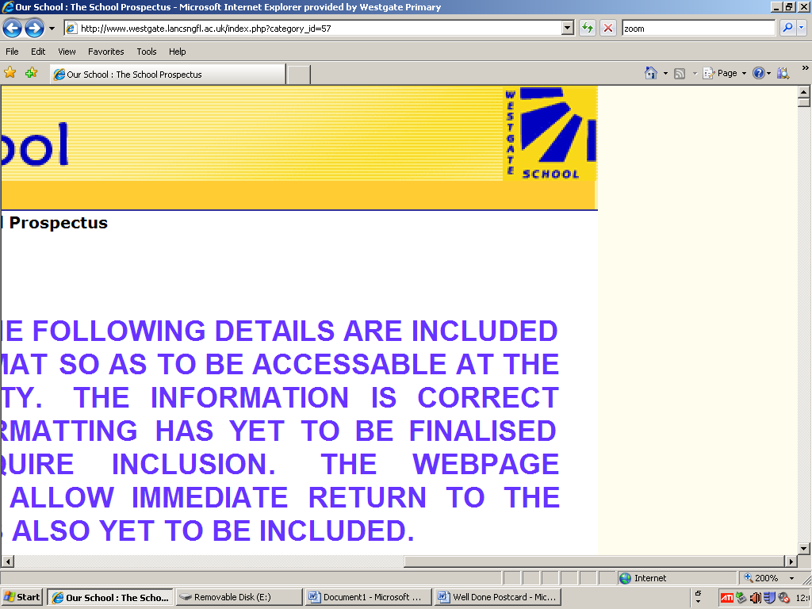

**WESTGATE PRIMARY SCHOOL**

**Safeguarding and Promoting**

**the Welfare of Children policy**

Child Protection is an integral part of ‘Safeguarding and Promoting Welfare’, however, the safeguarding agenda requires us all to think more pro-actively and consider what we can do to prevent and promote as well as to protect.

The diagram shows some of the key areas which are integral parts of ‘Safeguarding and Promoting Welfare’ in and for schools and educational settings.

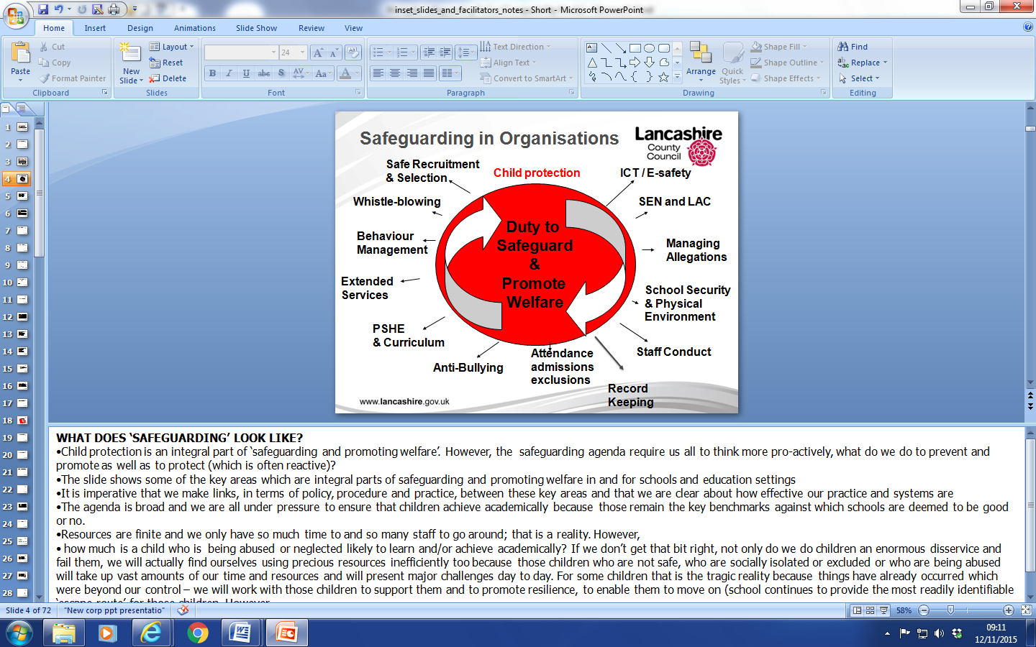

**Westgate Primary School Safeguarding Children Statement**

At Westgate Primary School the safety and welfare of all children is of paramount importance. Parents send their children to school each day with the expectation that school provides a secure environment in which their children can flourish. Westgate Primary School therefore has to ensure that this expectation becomes reality. In order to do this a wide range of measures are put in place.

The government published the statutory guidance ‘Keeping Children Safe in Education’ (March 2015) and the statutory guidance on inter-agency working ‘Working Together to Safeguard Children’ (March 2015).

Westgate Primary School has used this in formulating its own safeguarding statement.

**The Health and Safety Policy**

The school has a health and safety policy, which is monitored annually by the relevant committee of the school governors. A copy of this policy is available with 24 hours notice.

The LEA produces a monitoring checklist, which has to be completed on a yearly basis. The Headteacher, the Co-ordinator with responsibility for Health and Safety, the Site Supervisor and the Governors with responsibility for Health and Safety oversee this comprehensive list. Any concerns from staff are reported to any of the above and the site supervisor carries out an initial examination, assessing what remedial action needs to take place.

Each term there is a fire drill that practices efficient evacuation from the buildings. The school conducts an annual Fire Risk Assessment.

**First Aid**

In school there are always trained members of staff who volunteer to oversee first aid. There are a number of first aid kits situated around school. When a child is poorly, or has suffered an accident in school or on the playground there is a protocol for staff to follow:

* A trained first aider is consulted
* The incident is logged in the accident book
* For head injuries a Head Note is issued
* If there is any doubt at all a parent is contacted.

Westgate Primary School policy is that only nominated members of staff will give medicines following an agreement with the pupil’s parents. In the case of a pupil needing medication during the day parents are also welcome to come into school to administer correct dosages. For the majority of medicines a dose before and after school is perfectly adequate. Naturally the parents should consult doctors before giving any form of medication.

For matters of an intimate nature, staff deal with a child with utmost sensitivity and always to seek guidance from the Headteacher or Deputy. In almost all situations the parents will be asked to come into school immediately so that they are part of the decision making process for such matters. In rare circumstances the school nurse will be contacted as a matter of utmost urgency.

**Site Security**

Westgate Primary School provides a secure site, which is controlled by precise management directives, but the site is only as secure as the people who use it. Therefore all people on the site have to adhere to the rules, which govern it. Laxity can cause potential problems to safeguarding. Therefore:

Gates should be locked except at the start and end of each day.

Doors should be closed to prevent intrusion but to facilitate smooth exits.

Visitors, volunteers and students must only enter through the main entrance and after signing in at the office window.

Children will only be allowed home with adults with parental responsibility or confirmed permission.

Empty classrooms should have closed windows.

Children should never be allowed to leave school alone during school hours, and if collected by an adult, signed out.

Should a child leave the school premises without permission then staff have been informed never to chase after a child, but rather to report immediately to the office. Then parents and police will be informed of the circumstances.

**Attendance, Admissions and Exclusions**

Excellent attendance is expected of all children, but when children are unwell parents are expected to confirm absence by telephone immediately. If there is no notification school has a policy of phoning home to ascertain each child’s whereabouts.

Attendance rates are reported each term to the LEA, annually to the government and to all parents. Positive measures are in place to encourage children to attend regularly and punctually and the school is aware of its right to take legal action against parents who do not ensure good attendance and punctuality.

**Safe Recruitment and Selection**

All staff that are appointed to work in school have a criminal records search called a DBS check. This search highlights people who have a criminal record or if previous allegations have been made against them. If staff are found to have a criminal record the appointment is reconsidered by the Headteacher and the Personnel committee of the Governing Body. The LEA is informed directly by the Criminal Records Bureau.

The Headteacher sits on all appointment panels where the candidates are external applicants. The Headteacher has undertaken the LA training on Safer Recruitment

New staff are inducted into safeguarding practices. Newly appointed staff are assigned a mentor for the induction period. It is the responsibility of the mentors to familiarise new staff with procedures and policy, which affect the health and safety of all at school but especially the children.

**Induction of Volunteers**

Volunteers must also have Disclosure and Barring Service clearance. For a brief activity, such as a school visit, which does not involve the supervision or close contact of children the school may telephone for a “99” check. For extended contact with children, when children may be left alone with an adult, or when an adult visitor may be in and around the school building a full DBS search will be conducted. The office performs this. Visitors who do not yet have clearance will under no circumstance be left alone with a child or group of children.

**Welcoming Visitors**

It is assumed that visitors with a professional role i.e. the School Nurse or members of the police already have relevant clearance but the office will endeavour to check this before admittance is granted and a note made of anyone entering without clearance (see also Site Security). Services regularly accessing school will also provide a statement letter informing school that all members of the service have appropriate CRB clearance and in this case the school will then check the identification of visitors from the service.

**Child Protection Policy**

**Child Protection Governor**: Martyn Jowett (Governor)

**Designated Senior Person**: Steve Robinson (Headteacher)

**Backup Designated Senior**: Heather Fowler (Pastoral Manager)

Vicky Hodgson (SENCO)

There is a detailed Child Protection Policy, which is available from the school office with 24 hours notice. It is the Governing Body’s duty to ensure the policy is reviewed annually and any deficiencies within the policy addressed immediately.

In a situation where it is deemed necessary to use physical restraint, the school follows DfE guidance which asserts that physical restraint may be used if there is the possibility that a child may be about to cause harm to him/ herself or to another. It also asserts that on no occasion should such physical contact be used as a punishment.

**Managing Allegations**

All allegations of abuse by or complaints against a teacher will be dealt with according to the schools Managing Allegations and Whistle Blowing Policies. A copy of these are available at 24hours notice. For any complaints about the Headteacher the Chair of Governors should be contacted directly.

**Our Curriculum**

The curriculum deals with safeguarding in two ways. Firstly, the curriculum, in subjects such as Personal, Social and Health Education discusses relevant issues with the children. Topics include such themes as Drugs, Sex and Relationships and Stranger Danger. Children are encouraged to explore and discuss these issues. All children access ‘Kidsafe’ sessions in class.

Secondly, the curriculum is designed so that safety issues within the subject are discussed and safe practices taught, such as using equipment properly in PE and Design and Technology. At all times there has to be appropriate staffing levels and when the curriculum is taking out of school appropriate and agreed pupil/adult ratios are maintained. The lead adult always assesses visits as to the level of risk and all trips are finally authorised by the Headteacher / Educational Visits Co-ordinator (EVC).

Visiting speakers, with correct clearance are always welcome into school so that they can give specialist knowledge to the children.

**ICT and E-Safety**

Children should be encouraged to use the internet as much as is possible, but at all times in a safe way. Parents are asked if they agree to their child using the internet. Pupils must never be left unattended whilst online and teachers should ensure that this does not happen. If teachers know of misuse, either by a teacher or child the issue should be reported to the Headteacher without delay.

**Equal opportunities**

Within the school prospectus there is a statement for equal opportunities which asserts:

“At Westgate Primary School we try to ensure that everyone is treated fairly. All children are given equal access to the school and its curriculum and all at Westgate Primary School are considered equal in the learning partnership. When children have special needs we make arrangements to inform parents and design specific programmes”.

Children with disabilities must be able to take a full and active part in every lesson and every measure must be taken to ensure this.

**Behaviour Management**

Good behaviour is essential in any community and at Westgate Primary School we have high expectations for this. A Behaviour Policy is included in the Handbook detailing the rewards and sanctions available to staff. Although the emphasis is always on the positive there are also times when a consequence must be given for inappropriate behavior, in order to maintain the safety and security of all children.

There are numerous rewards available to children:

* Stickers / Gems
* Showing another teacher good work
* Points leading to awards
* Certificates
* Cups / Trophies
* Golden Time

 But consequences range from:

* Discussion of behaviour
* Being removed from class
* Use of traffic light system (Reception / Key Stage One)
* Use of verbal warnings, yellow and red cards (Key Stage Two)
* Loss of Golden Time Reward
* Loss of playtime
* Reporting to a senior member of staff
* A letter home
* Exclusion

Staff are discouraged from handling children, but when they deem it is safest to do so guidance has been given on safe methods of restraining a child so that they do not harm either themselves or others.

**Anti Bullying Policy**

The Westgate Primary School definition of bullying is: “A systematic and extended victimisation of a person or group, by another or group of others.”

The school’s response to this is unequivocal.

Adults must be informed immediately and action will take place.

Children are told that silence is the bully’s best friend. Although bullying in this school is rare the school always acts swiftly with a process of investigation, communication and action. Bullies will not be tolerated.

There is a more detailed Anti-bullying Policy that is available from the school office at 24 hours notice.

**Racial tolerance**

Along with the equal opportunities statement there is a statement in the prospectus that asserts:

“At Westgate Primary School pupils will be prepared for an ethnically diverse society. The school will work hard to promote racial equality and harmony by preventing and challenging racism.”

“If anyone ever feels unjustly treated then the school welcomes and values a response. It is in working together that we will make Westgate Primary School even better.”

Racism is tackled in both the RE and in the PSHE curriculum. The children take part in discussions designed to raise awareness and address prejudices.

**Photographing and Videoing**

There has been a lot of controversy recently about adults photographing and filming young people. The concerns are genuine, however at Westgate Primary School we have taken a sensible, balanced approach, which allows parents to photograph and file providing they follow certain guidelines:

* Parents consent to school taking photographs by signing a permission slip at Parents’ Evening or upon entry to school. School photographs that are for use outside of school are anonymous unless specific permission has been received from parents.
* Parents taking photographs read the LEA advice leaflet.
* Parents will in the future be asked to sign to say that they have read the document prior to using their camera.

**Whistle blowing**

If members of staff ever have any concerns about people working, paid or unpaid, they have a professional duty to inform the management accordingly. This can be done in writing or verbally but staff should be prepared to discuss issues in the confidence that any such matter will be dealt with sensitively and with the necessary degree of confidentiality. The school follows the Local Education Authority’s draft policy on Whistle blowing. A copy of this can be made available at 24 hours notice.

**Date Of Review:** January 2016

**Next Review Date:** January 2017

