Dear Reception children, Parents and Carers,
Firstly well done everyone on some brilliant work about monsters, we have loved hearing about what you have been doing and seeing some lovely work. This week we are going on a journey with a snail and a whale.
Here is a list of suggestions of activities you could complete this week. They can be done in any order and it is up to you how many you do. Enjoy.
Activity 1 | Read the story ‘The Snail and The Whale’ by following the link on the sheet. Stop the story at different places and see if you can predict what is going to happen next? Were your predictions right? Talk about what we know about the snail and the whale in the story, e.g. The snail is tiny and it has an itchy foot. The whale sang a song to the snail. Listen to the story again, to find out more. Then can you draw a picture of the snail or the whale and label it? Could you then write a sentence about the snail or the whale? For example ‘The whale is big’. There is some lovely whale paper for you to use.
Activity 2  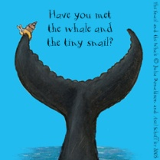 | Watch ‘The Snail and the Whale’ film by following the link on the sheet. Pause the film at different points to spot all the animals in the story. You could play I spy, e.g. I spy, with my little eye, something beginning with …  Can you now make a list of all the different animals you can ‘spy’ throughout the film – there are lots! There is some lovely under the sea paper for you to use.
Activity 3  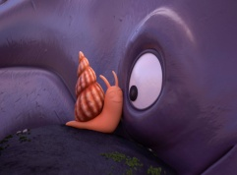 | Using either the book or the film show the children a busy picture with lots going on and discuss what you can see. For example seagulls, lighthouse, anchor. Use the sentence I can see a...... and now can you expand it by telling your grown up more. For example I can see a lighthouse and it is red and white. Using different pictures can you write the sentence I can see a...... about what you can see. There is some lovely paper for you to use.
Activity 4 | The snail and the whale visit lots of different places on their travels. Can you remember where they went? Could you write them a postcard about either where you live or where you have been on holiday? What did you do there? Was it hot or cold? Who did you go with? Maybe they might come and visit Morecambe now. There is a postcard template available for you to use if you would like.
Activity 5  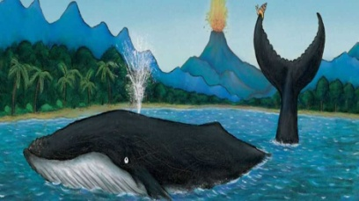 | The whale in the story is a Humpback Whale, can you find out all about humpback whales here:  Humpback Whale – Animals for Kids https://www.youtube.com/watch?v=joBvuEJyUd0  Can you write some facts down in sentences, using your phonics to help? There is some lovely whale paper for you to use.  Watch this clip where the TV presenter is taken by surprise: Steve gets a surprise from a humpback whale https://www.bbc.co.uk/cbbc/watch/deadly-60-norway-humpback-whale-surprise

As always when you are writing don’t forget to rehearse your sentences out loud, just like we do in class. Perhaps you could use your pencil as a microphone! Also use all your phonic skills, make sure you sound out the words before you write them. You are all brilliant at this so impress your Mummy’s and Daddy’s with your sounding out. Don’t forget those phoneme fingers.
Your sound mats will be helpful too as will the letter formation sheet. A few weeks ago we included a tricky word mat and our Reception key words to help with your writing. Keep using these in your writing.
Enjoy the unit and we can’t wait to hear how you get on!
Mrs Ronayne, Mrs Livingstone and Ms Chapman

